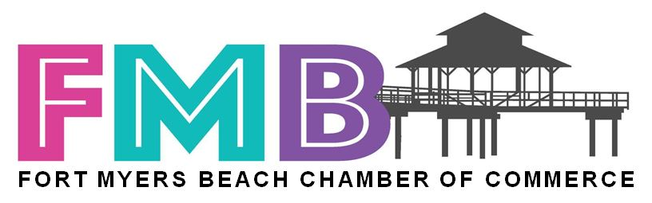

Chairperson of the Board – Gail Langner

Past Chair – Ron Clayton

Vice Chair - Chuck Bodenhafer

Vice Chair – John Gavin

Vice Chair - Bill Behrens

Vice Chair – Bob Beville

President - Jacki Liszak

**FORT MYERS BEACH CHAMBER OF COMMERCE**  
**RESOLUTION NO. 25-04**

**A RESOLUTION OF THE FORT MYERS BEACH CHAMBER OF COMMERCE BOARD OF DIRECTORS REITERATING STRONG SUPPORT FOR FORT MYERS BEACH ELEMENTARY SCHOOL, ITS STUDENTS, PARENTS, AND COMMUNITY; AND URGING THE LEE COUNTY SCHOOL DISTRICT TO HONOR THE INTERLOCAL AGREEMENT AND CEASE ACTIONS DETRIMENTAL TO THE SCHOOL AND COMMUNITY**

WHEREAS, the Fort Myers Beach Chamber of Commerce (“Chamber”) represents the businesses, residents, and guests of Fort Myers Beach, Florida, and is committed to advocating at the local, state, and federal levels to improve the community’s quality of life, education, and business climate; and

WHEREAS, Fort Myers Beach Elementary School (“FMBE”) serves as a vital educational, social, historic, and cultural cornerstone of the island community, educating generations of local children and contributing to the overall well-being, stability, and identity of Fort Myers Beach; and

WHEREAS, the Town of Fort Myers Beach and the Lee County School District entered into a legally binding Interlocal Agreement (“ILA”) to rebuild, operate, and maintain FMBE following Hurricane Ian, including a phased rebuilding plan, a cafeteria building, and provisions for expanding capacity as enrollment grows; and

WHEREAS, the Fort Myers Beach community, parents, students, Town Council, and local businesses have acted in good faith to support FMBE’s reopening, enrollment, and operational success, including honoring every aspect of the ILA and providing consistent community engagement; and

WHEREAS, the School District of Lee County has received a **$11.4 million award from the Federal Emergency Management Agency (FEMA)** as part of a broader $19.5 million disaster recovery project to repair, rebuild, and restore Fort Myers Beach Elementary School to safe, modern, and fully operational capacity; and

WHEREAS, the Lee County School District has, over the past several years, conducted internal and external assessments of FMBE, including but not limited to:

1. The **Castaldi Report**, (Facilities Assessment Report), assessing the viability of the FMBE campus. detailing the condition of buildings, estimated cost of repairs, and programmatic and operational limitations due to storm damage and recommending demolition or replacement due to hurricane-related structural vulnerabilities; and

WHEREAS, despite the availability of FEMA funding, adherence to the ILA, and ongoing good-faith efforts by the Town and community, the School Board, on **October 7, 2025, voted to raze the Fort Myers Beach Elementary School building**, citing the Castaldi and Facility Assessment reports; and

WHEREAS, this vote was **added at the last minute to the consent agenda**, without prior notice, public discussion, or consultation with the Town, parents, FMBE Ad Hoc Committee, or the broader Fort Myers Beach community, leaving the community completely unaware that demolition was being considered; and

WHEREAS, the Chamber recognizes that hurricane damage and coastal flooding present real challenges, but the last-minute, non-transparent decision undermines trust, violates the spirit and intent of the ILA, and disregards years of community investment, planning, student stability, and phased rebuild commitments; and

WHEREAS, parents, Ad Hoc Committee members, and Town officials have documented **ongoing harm** from these actions, including disrupted educational continuity, emotional distress for students, reduced enrollment, instability in staffing, and diminished community confidence, as a direct result of District actions and failure to uphold the ILA; and

WHEREAS, the Town of Fort Myers Beach has taken formal action by **requesting mediation pursuant to the ILA** to address grievances and enforce compliance, with the first mediation session scheduled for November 5, 2025, at Town Hall; and

WHEREAS, the Chamber acknowledges the critical importance of **transparency, community input, and the utilization of federal funds** to ensure FMBE’s long-term viability, safe operation, and educational continuity.

NOW, THEREFORE, BE IT RESOLVED THAT:

1. The Fort Myers Beach Chamber of Commerce **unequivocally supports Fort Myers Beach Elementary School**, its students, staff, and families, reaffirming that the school is a critical and irreplaceable part of the island community.
2. The Chamber **strongly opposes the School Board’s October 7, 2025 vote to raze FMBE**, added last minute to the consent agenda without notification or public engagement, and deems this action in **direct conflict with the ILA** and harmful to students, staff, families, and the broader community.
3. The Chamber **demands the Lee County School District honor all obligations under the ILA**, including the phased rebuild plan, operational funding, and promised facilities, and immediately cease actions that disrupt enrollment, staffing, or programs.
4. The Chamber **calls on the District to provide transparent, timely, and actionable communication** to students, parents, and the community, including detailed plans, timelines, updates regarding facilities, staffing, and program continuity, and public release of all supporting reports, including the Castaldi and Facility Assessment reports.
5. The Chamber **urges the District to fully utilize the $11.4 million FEMA award** to restore, repair, and modernize FMBE as intended, rather than demolish critical facilities.
6. The Chamber **supports the Town of Fort Myers Beach in its mediation efforts** to enforce the ILA, protect the school, and resolve grievances, and will advocate for additional measures necessary to safeguard students, families, and community interests.
7. The Chamber affirms that **continued non-compliance or unilateral decisions by the District will have serious consequences**, including potential legal action, erosion of public trust, and harm to the children and families of Fort Myers Beach.

PASSED AND ADOPTED by the Board of Directors of the Fort Myers Beach Chamber of Commerce on this 8th day of October, 2025.

________________________

Jacki Liszak

President and CEO

**FORT MYERS BEACH CHAMBER OF COMMERCE**

**100 Lovers Lane, Ste. 3E, Fort Myers Beach, Florida 33931**

**(P) 239-454-7500**

[**www.fortmyersbeach.org**](http://www.fortmyersbeach.org)